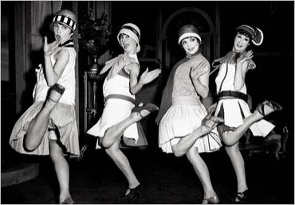
1920s Presentations
Take notes in the columns with what information that you think is most important. You will need this to help you with discussions on the final day.
Topic | Information | Key Words

3-2-1
At the end of the party, you need to fill in this paper, and turn it in by the end of the class.
3 things I learned: ________________________________________________________________________________________________________________________________________________________________________________________________________________________________________________________________________________________________________________________________________________________________________________________________________________________________________________________________________________________________________________________________________________________________________________________________________________________________________________________________________________________________________________________________________________________________________________________________________________________________________________________________________________________________________________________________________________________________________
2 things I still have questions about:
____________________________________________________________________________________________________________________________________________________________________________________________________________________________________________________________________________________________________________________________________________________________________________________________________________________________________________________________________________________
1 thing I want Miss Hawes to know:
________________________________________________________________________________________________________________________________________________________________________________________________________________________________________________________________________________________________________________________

