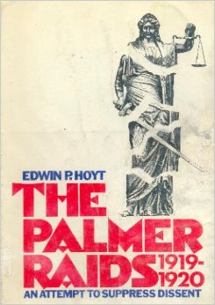

Palmer Raids Background

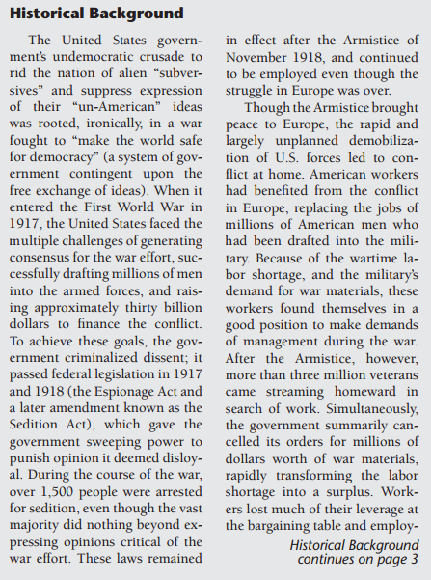
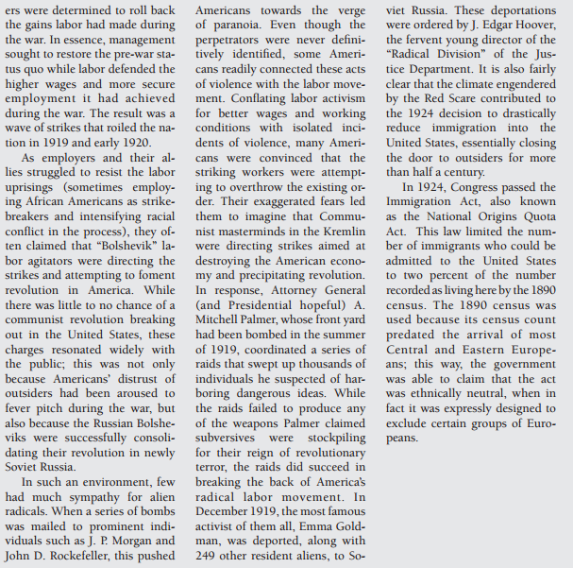
Close Reading
- Read through and Circle any unfamiliar words. Define them in the margins
- Read through and highlight key points.
- Read through and annotate the document. Formulate two questions.
  - _________________________________________________________________________________________________________________________________________________________________________________________________________
  - _________________________________________________________________________________________________________________________________________________________________________________________________________

